Safe and inclusive ferries for everyone.

Working towards a Hate Crime Charter for Caledonian MacBrayne Ferries (CalMac)

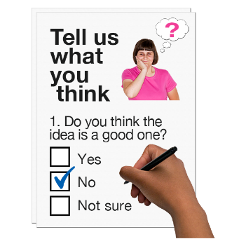

Copyright images © Photosymbols. Prepared by Disability Equality Scotland
 | CalMac and Disability Equality Scotland, with support from Transport Scotland’s Ferries Accessibility Fund are working together.
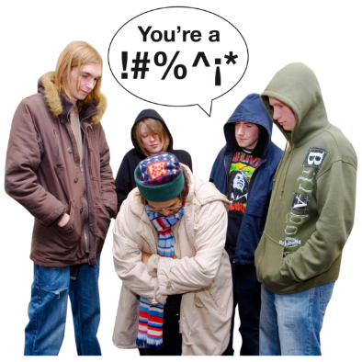 | We want to have a transport system that is safe and comfortable for everyone to use.  We want to stop hate crime on public transport and make everyone feel safe to travel.  People need to know how to report hate crime.
What is hate crime?
Hate crime is not when you just hate someone.
A hate crime is when someone does something to hurt you because of who you are or who they think you are.
Someone might think you are different from them and hates you because of that difference.
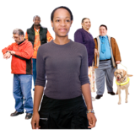 | Someone might think you are different because of your disability, race, religion, sexual orientation or gender identity.
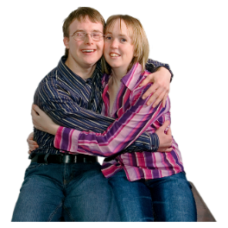 | Sexual orientation means what kinds of people you love or have sexual or romantic feelings about.
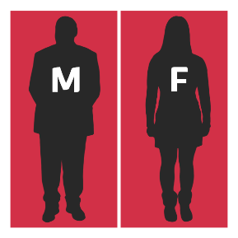 | Gender identity means if you see yourself as male or female or in another way.
To help us with our work, fill in this survey about what it is like travelling with CalMac.
Please answer the questions as honestly as you can.
There are no right or wrong answers.
You can fill out the survey on your computer, then save it and email it to:
fiach@disabilityequality.scot

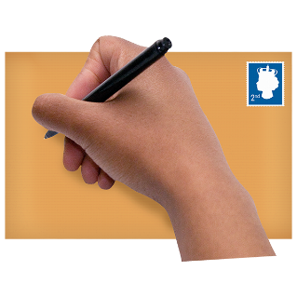 | Or you can print a copy of the survey, fill in the answers and post it to:  Disability Equality Scotland  Suite 204B  The Pentagon Centre  36 Washington StreeT  Glasgow  G3 8AZ
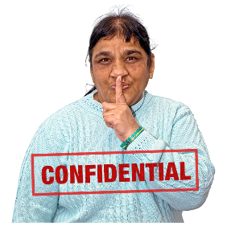 | Your replies are confidential.  No-one will know it is you and your information will be kept private.  We will keep your information until the end of the project in March 2021.
Tick the box of the answer you agree with and a tick will appear. ☐

If you change your mind you can click on it again to untick it.

Where there is a dotted line, type your answer.

If you are filling out a paper copy, tick the box of the answer you agree with, or write your answer on the dotted line.
Miss out any questions that make you feel uncomfortable.

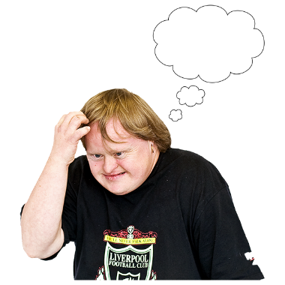 | - In your life how worried are you about hate crime?
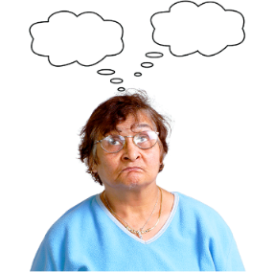 | Not worried | ☐
 | A bit worried | ☐
 | Very worried | ☐
 | - When you use a CalMac ferry how worried are you about being a victim of hate crime?
 | Not worried | ☐
 | A bit worried | ☐
 | Very worried | ☐
 | - How safe do you feel travelling on the ferry?
 | Not safe | ☐
 | A bit safe | ☐
 | Very safe | ☐
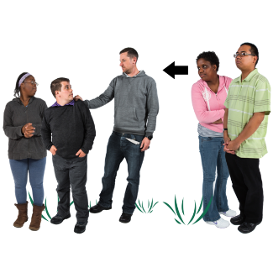 | - Have you seen or known about hate crime on a CalMac ferry before?
 | Yes | ☐
 | Maybe | ☐
 | No | ☐
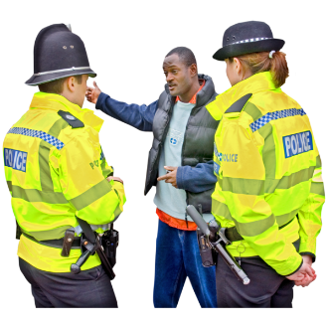 | - How confident would you be to report a hate crime in these places?
At my home

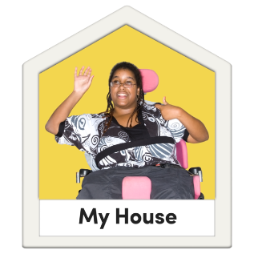 | Not confident | ☐
 | A bit confident | ☐
 | Very confident | ☐
At the shops
 | Not confident | ☐
 | A bit confident | ☐
 | Very confident | ☐
On the ferry
 | Not confident | ☐
 | A bit confident | ☐
 | Very confident | ☐
On the bus
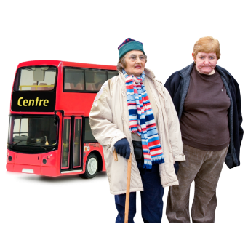 | Not confident | ☐
 | A bit confident | ☐
 | Very confident | ☐
On the train

 | Not confident | ☐
 | A bit confident | ☐
 | Very confident | ☐
At my work

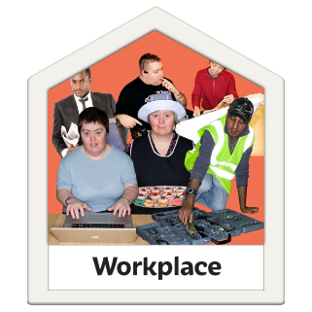 | Not confident | ☐
 | A bit confident | ☐
 | Very confident | ☐
In the street

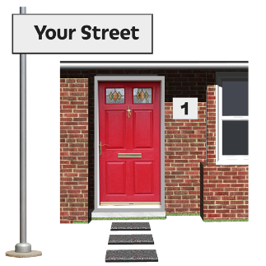 | Not confident | ☐
 | A bit confident | ☐
 | Very confident | ☐
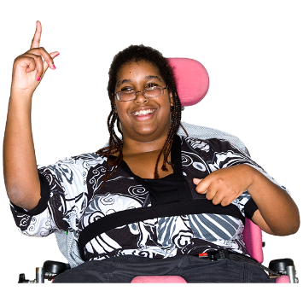 | - Do you consider yourself to have a disability, long-term illness or health condition?  Yes ☐ No ☐
 | If yes, and you are happy to, tell us the type of disability or health condition that you have.
 | Physical disability | ☐
 | Learning disability | ☐
 | Mental health | ☐
 | Sensory disability | ☐
 | Other | ☐
If you chose other, write your answer here:
…………………………………………………………………………
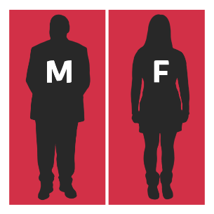 | - What is your gender?  Gender means do you see yourself as a man or a woman or in a different way?
 | Male | ☐
 | Female | ☐
 | Other | ☐
 | - How old are you?
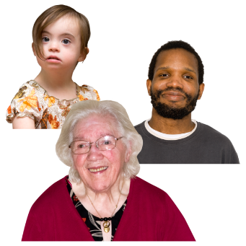 | Under 18 | ☐
 | 18-24 | ☐
 | 25-34 | ☐
 | 35-44 | ☐
 | 45-54 | ☐
 | 55-64 | ☐
 | 65 or older | ☐
- . What is your religion or belief?
A religion is a set of beliefs that some people have. There are many different religions, each with a different set of beliefs.
 | Church of Scotland | ☐
 | Roman Catholic | ☐
 | Other Christian | ☐
 | Muslim | ☐
 | Buddhist | ☐
 | Sikh | ☐
 | Jewish | ☐
 | Hindu | ☐
 | Pagan | ☐
 | Other | ☐
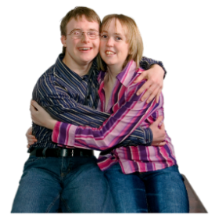 | 11. What is your sexual orientation?
 | Straight/heterosexual | ☐
 | Gay/lesbian | ☐
 | Bisexual | ☐
12. What is your ethnicity?
Ethnicity is the word we use to describe our background. People from an ethnic group might have the same language, culture or religion.
 | White - English / Welsh / Scottish / Northern Irish / British | ☐
 | White - Irish | ☐
 | White - Gypsy or Irish Traveller | ☐
 | White - Any other White background | ☐
 | Mixed / Multiple ethnic groups - White and Black Caribbean | ☐
 | Mixed / Multiple ethnic groups - White and Asian | ☐
 | Mixed / Multiple ethnic groups - Any other Mixed / Multiple ethnic background | ☐
 | Asian / Asian British - Indian | ☐
 | Asian / Asian British - Pakistani | ☐
 | Asian / Asian British - Bangladeshi | ☐
 | Asian / Asian British - Chinese | ☐
 | Asian / Asian British - Any other Asian background | ☐
 | Black / African / Caribbean / Black British - African | ☐
 | Black / African / Caribbean / Black British - Caribbean | ☐
 | Black / African / Caribbean / Black British - Any other Black / African / Caribbean background | ☐
 | Black / African / Caribbean / Black British - Other ethnic group | ☐
 | Arab | ☐
 | Any other ethnic group | ☐
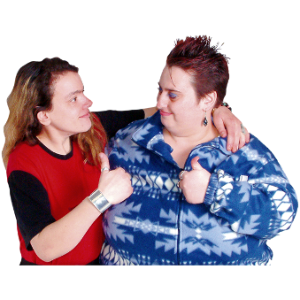 | Thank you for sharing your experiences with us.  What you tell us is important.
If you would like to find out more information about how to stay safe look online at the Disability Safety Hub.
www.disabilitysafety.scot

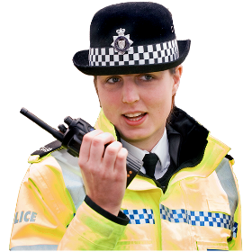 | The Hub was developed by Disability Equality Scotland in partnership with Police Scotland.  It will help you know what hate crime is and how to report it.
 | If you have any questions email: fiach@disabilityequality.scot

Copyright images © Photosymbols. Prepared by Disability Equality Scotland

